**LAB # 05**

**“ IMPLEMENTING MULTI-LAYER NEURAL NETWORK USING KERAS ”**

* **OBJECTIVE:**

To implement a neural network with multiple hidden layers and understand how hidden layers

help the model learn better patterns.

* **LAB TASKS:**

**TASK 1:** Change the number of neurons in both hidden layers (e.g., try [3, 2], [6, 4], or [2, 1]) and observe:

• Training accuracy

• Predictions

• Does the performance improve or drop?

* **CODE:**

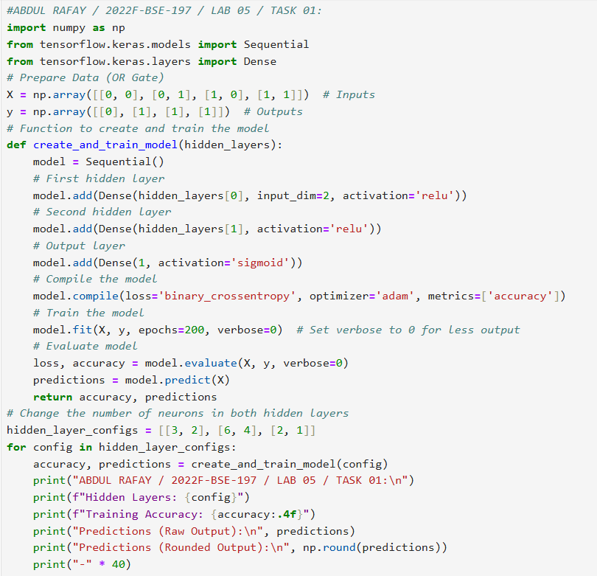

* **OUTPUT:**

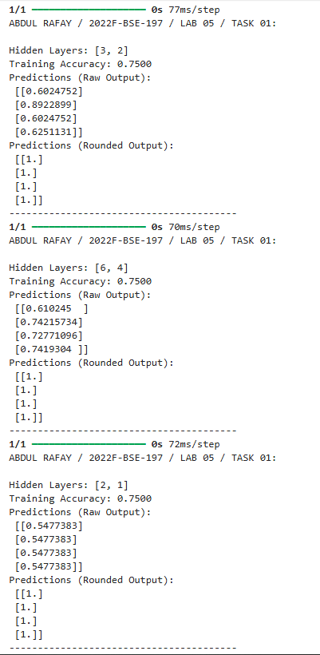

**TASK 2:**

**1.** Replace relu with tanh in both hidden layers.

**2.** Replace relu with sigmoid in both hidden layers.

**Compare:** training time, accuracy, and predictions.

* **CODE:**

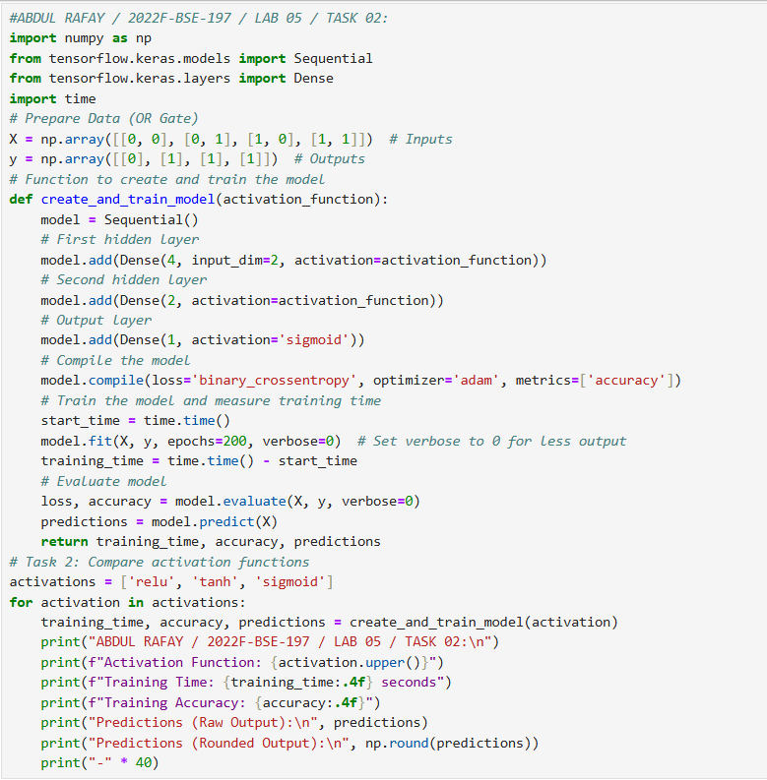

* **OUTPUT FOR RELU:**

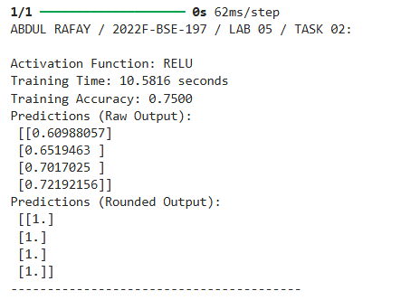

* **OUTPUT FOR TANH:**

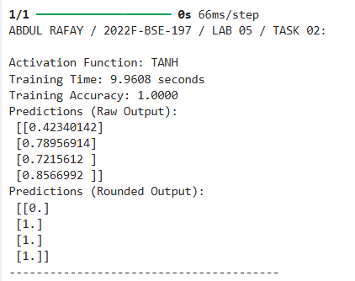

* **OUTPUT FOR SIGMOID:**

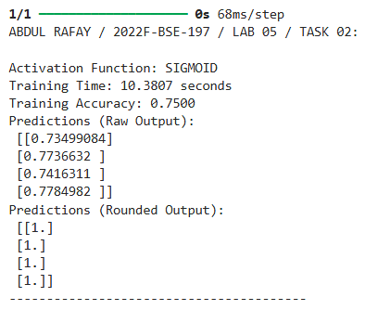

**TASK 3:** Change the optimizer:

• Try sgd, rmsprop, or adamax in place of adam.

* **CODE:**

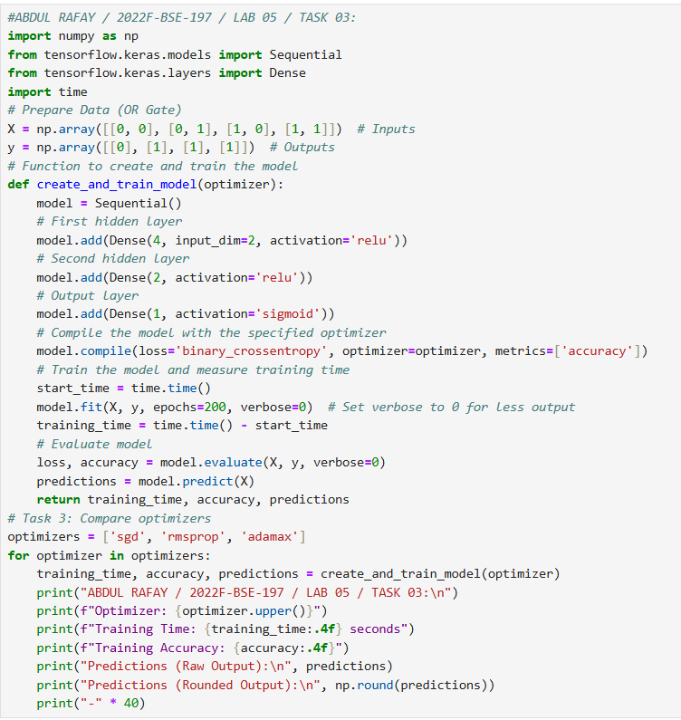

* **OUTPUT FOR SGD:**

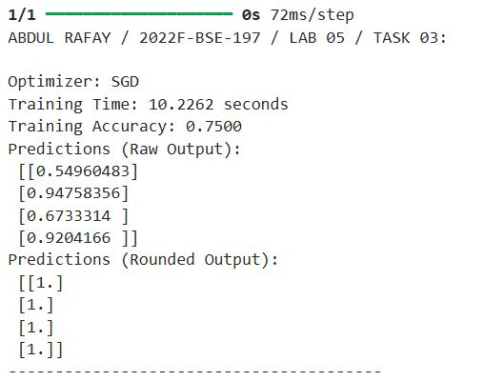

* **OUTPUT FOR RMSPROP:**

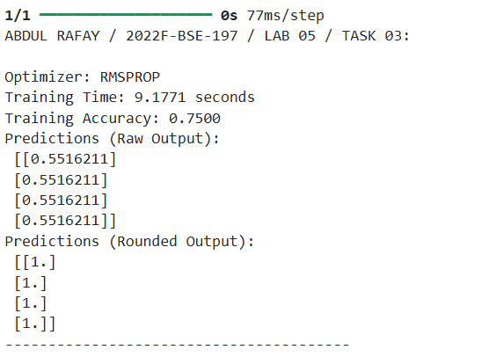

* **OUTPUT FOR ADAMAX:**

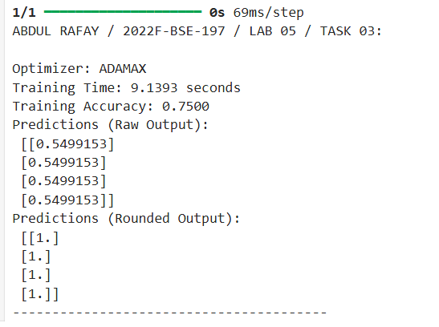

* **GITHUB UPLOAD:**

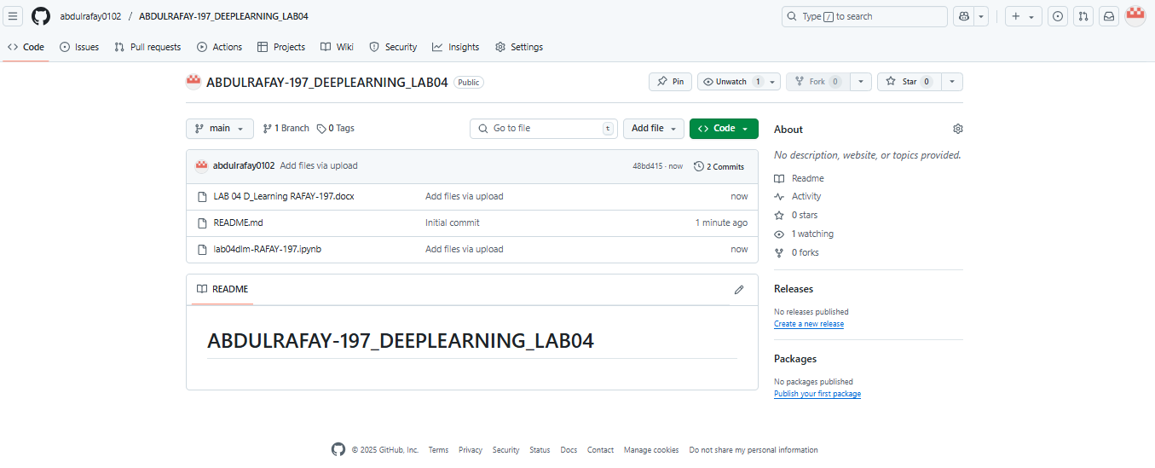

* **KAGGLE UPLOAD:**

